**Journalism Today!**

Journalism has experienced wide changes in the past decade from the way it works and delivers the contents to the local public. Journalism has been the best source for information spreading across the globe with facts and figures and the right information. However, the present-day scenario has been different for the way these journalism firms work.

People rely on various information and news on the journalists, they however seem to work more for the money and hide news due to various influences. The most recent case of ignorance shown by Journalism is the hiding of the Corona outbreak. Journalists helped China in hiding about the pandemic for a large time-span and that affected the world in the most adverse types.



In India too, journalists are hiding various cases about the virus attacks and siding with the government rather than disclosing the reality to the public. Journalists these days focus more on gossips and fake rumors then covering the right and true details happening worldwide. The target for journalism has turned towards the topics of who married whom, who is caught drunk, who all are having affairs, and other personal life issues.

**Most common changes in Today’s journalism:**

Journalism has changed widely, as stated by various examples above. Journalism has been the main source for spreading various news about not wearing masks compulsorily in the pandemic time, not to be scared of it as it is less fatal, and many more, and all these resulted in millions of cases, spread in them, and related deaths. Here are the few common changes seen in today’s journalism:

1. **Competition for taking the best clicks.**

The top journalist agencies are now focusing more on taking the best Clicks or photos for any important or even unimportant gossips. With this, they are competing with small firms, and thus focus on photography more than producing the best news. They are trying to attract various people by the clicks rather than by disclosing the exact and real happenings around the world.

1. **More focus in the rush to get the publishing done rather than to capture the perfect information.**

Journalism agencies pressurize journalists more in the rush to get the publishing done as soon as possible and to be the first one to disclose any news rather than to capture the complete news and them to publish. And because of this, there are various malfunctioning in the publishing like half of the news is right and half is just a rumor that is not verified because of the rush done before getting the stats confirmed.

1. **Focusing more on the news related to social media**

The social media business is most acrimonious and the journalists rely more on social media news platforms to seek an audience. Instead of important news, social media focuses more on trolling rather than publishing the correct information. With this, the center of attraction for journalism seems to change.

1. **Donations to change the facts and stats**

Journalism has been revealed to take various favors and donations for hiding the highlights and helping the influencers and government in the name of various favors and helps for being popular and successful.

1. **Discussing politics.**

Many of these journalism firms focus on politicization and thus lacks in capturing the informative news that is to be delivered about various happenings that are necessary for information and to be known across the globe.

**Journalism: Best or worse?**

Journalism is helping us with various information and resources and how things go around across the globe. Journalism sometimes also provides much unique news that is unknown and they tend to reach the final objectives about any hot topic by various analyses. They use easy to understand jargons for ease of their readers and spread pieces of information with various touches of humor to make the contents engaging.

Even though there are various benefits with journalism, there are a few worst facts about present-day journalism, like:

1. Their disbelief in any ultimatum leads to various confusion about the topics and thus becomes complex.
2. They target various celebrities and stars and troll them and also target them on various misbehaviors that are acceptable from the general public.
3. Hide the complete stats and deliver only half of the information.

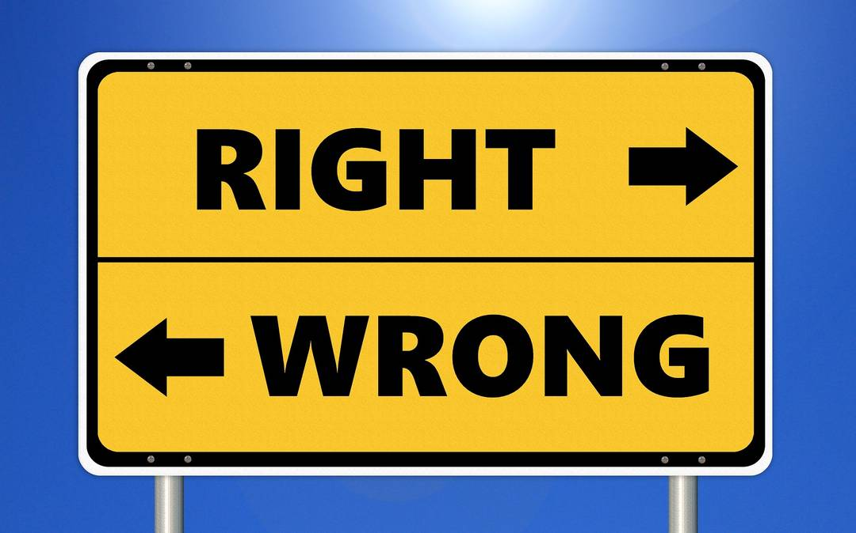

Just like every other agenda, journalism too has various pros and cons, and it depends on the individual journalists to be an asset or liability for the public!